|  |  |
| --- | --- |
| TEST SCENARIOS- AGENCY | |
| TEST SCENARIO-6 | Verify customer registration marital status with "UNMARRIED" |

|  |
| --- |
| **STEP-1:** |
|  |
| * The policies sold by the agent will be populated here. * Total number of policies sold by him will be displayed. * Number of policy he sold today, this month and this year will be populated * The premium paid by the customers registered under this agent will alos be auto populated * Click “next”.   **STEP-2:** |

* In this tab the life insurance policies, health insurance policies and unit linked insurance policies will be populated.
* Click “next”.

**STEP-3:**

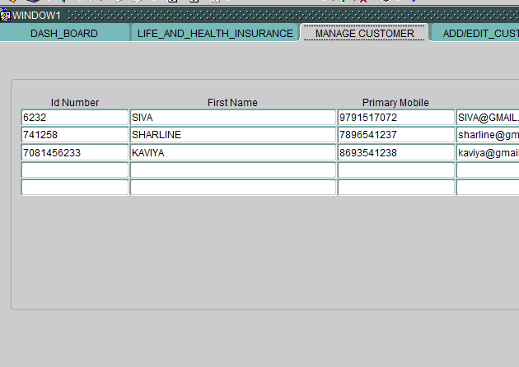

Here the id number, first name, mobile number and so on…

**STEP-4:**

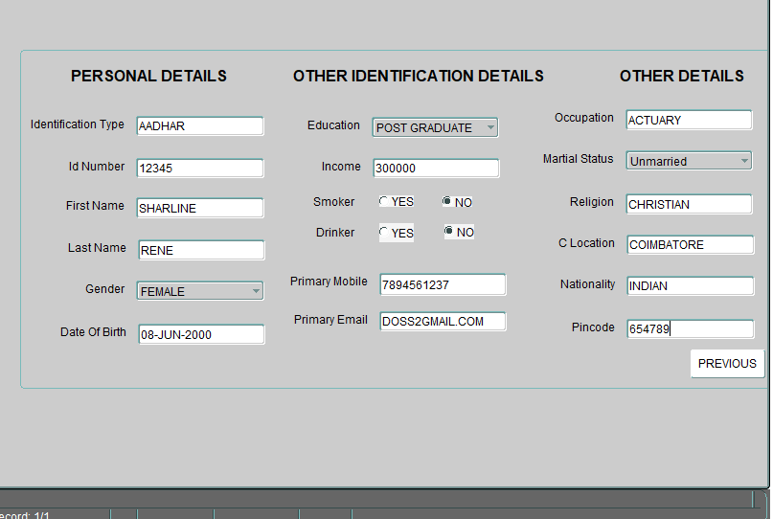

**In personal details,**

* Enter the identification type
* Enter the id number
* Enter first name
* Enter last name
* Select gender from LOV
* Enter date of birth.

**In other identification tab,**

* Select education details from LOV
* Enter income details
* Select smoker as “yes” or “no”
* Select drinker as “yes” or “no”.
* Enter primary mobile number.
* Enter primary mail id

**In other details tab,**

* Enter occupation details
* Select the marital status AS “UNMARRIED”
* Enter religion
* Enter location
* Enter pin code
* Click next

**STEP-5:**

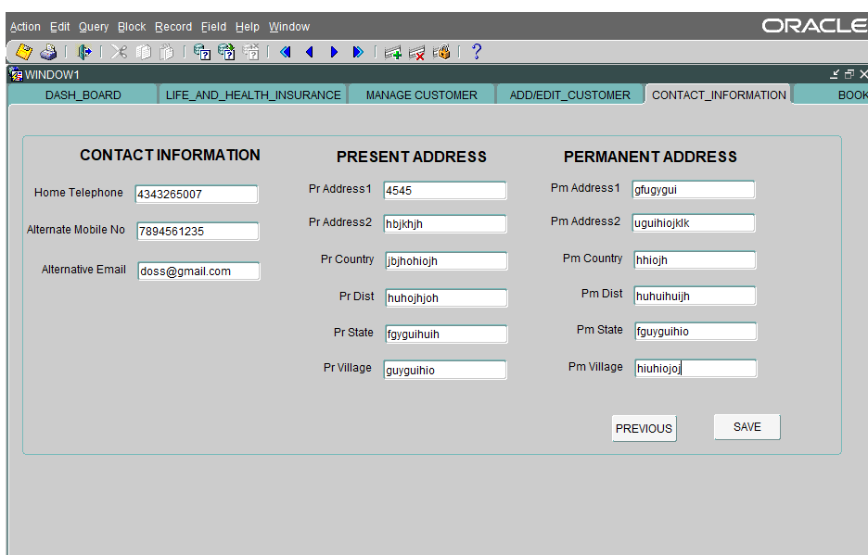

Enter the contact details

Enter the present address

Enter permanent address

Click save

**STEP-6:**

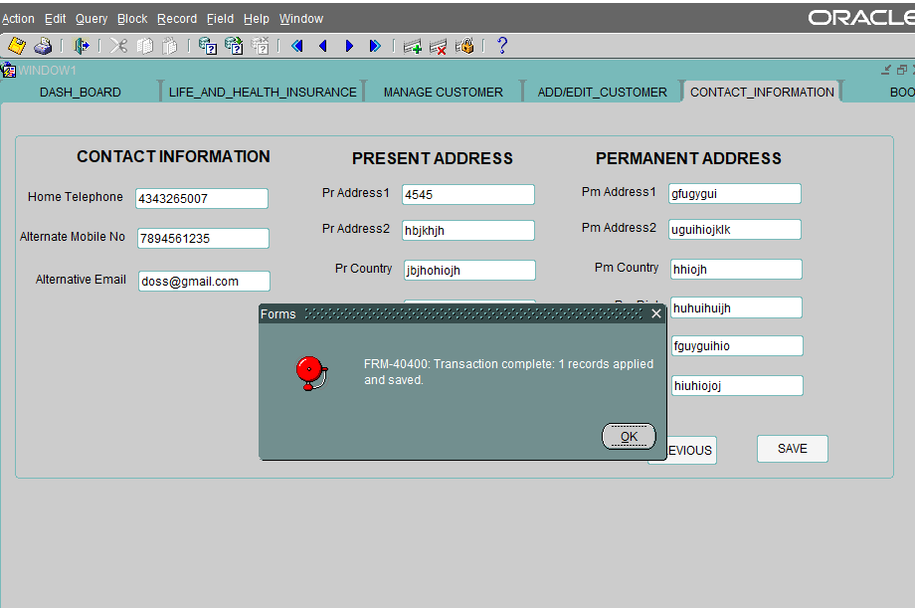

* “TRANSACTION COMPLETE” dialogue box will be populated.

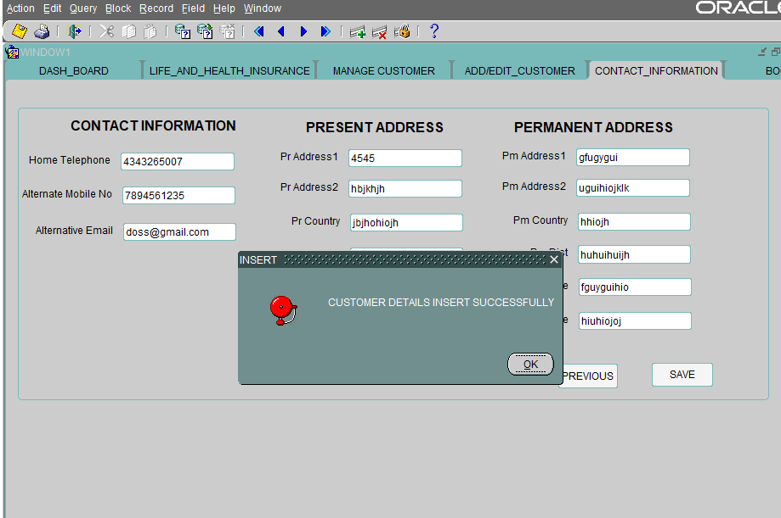

* “Customer details inserted successfully” message will be auto populated.

**STEP-7**

* Select all products from LOV
* Enter name, policy id, lead id premium amount and booked on date.
* To date will be calculated based on from date
* Click “next”

**STEP-8**

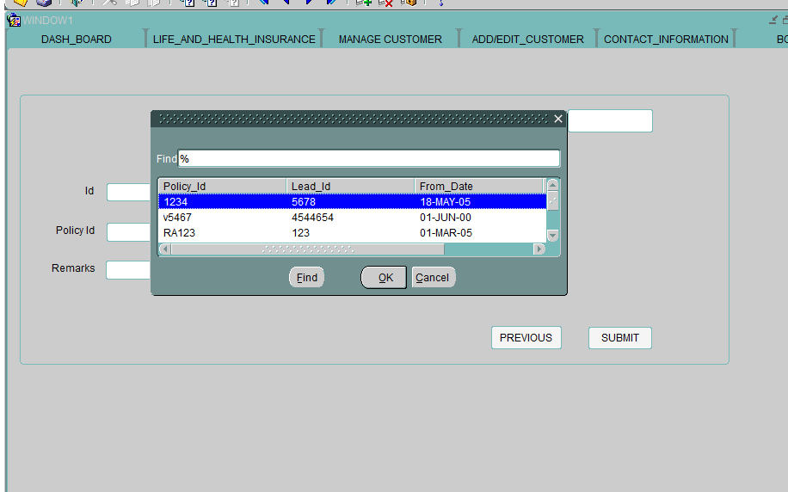

* The details of the customer is registered here.
* Click from the LOV
* Press “ok”
* Details will be populated as below.

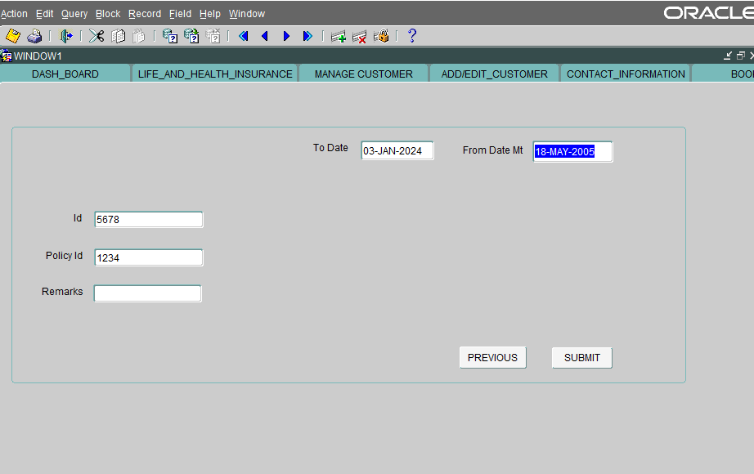

* Add remarks
* Click submit

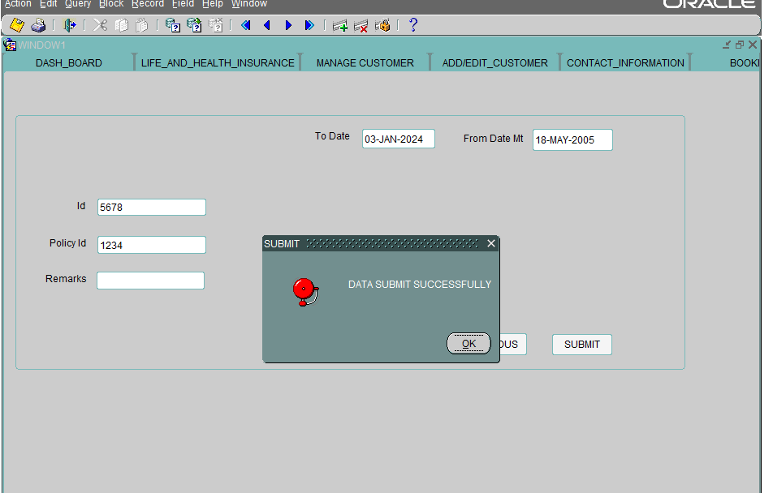

* “Data submit successfully” message will be displayed.
* The customer registered under agent with “unmarried” status is transacted successfully.